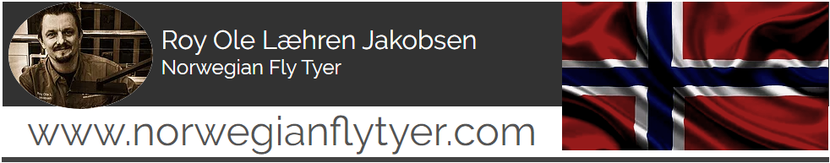

My name is Roy Ole Læhren Jakobsen and I`m born in 1977, raised in a small wooded valley close to the biggest lake in Norway, Mjøsa. Now I live in a place called Raufoss in the middle of Norway. Two hours north of the capital Oslo. I`m married with my beautiful wife, have two kids and have a foster son living with us.

In my childhood, fishing was my prime interest. I started fishing alone at the age of 8, and began tying my own flies when I was about 12 years old. I still remember I sat along the banks of river Orkla in Norway. Tied up salmon-tubes for the older fishermen. The flies actually gave them very good catches.
A fly tyer was born.

Fishing for brown trout is my passion of life, and it`s also reflects my fly tying. By tying dry flies, nymphs and streamers, I try to imitate what the trout feeds on, both over and under the surface. My main goal is to make the flies as fishy as they can be. They must have the appearance of being something natural and edible.

It is important to me that the flies have lot of life, naturalness and movement. I built in these features by selecting the appropriate materials as CDC, different types of hair, quills and capes. I also like to experiment around already established fly patterns with new materials. I want to give them “my look” by thoughts and experience. Another important thing that I search for, is how to get all this elements in my fly as quickly as possible. If I can tie a fishy fly in one minute instead of using 30 minutes on a photo-fly, I have no doubt what I want to do.

I mostly fish rivers and lakes in my home area. Either down in the lowland or up on the mountains. It all depends on where to expect an insect hatch. And my fishing season last from about April to September.
Once or twice a year I try to get on a slightly longer expedition, preferably up north in Norway, or abroad as Iceland, hunting for the big brown trout’s that lives there.

In 2017 I was so lucky to be able to join Semperfli`s fantastic PRO tyer team. They deliver all the materials a fly tyer can dream about. They are innovative and they have the fly tyer in the forehead when they making, and launching new products.
And in 2019 I was able to join the PRO tyer team of the Norwegian worldwide and very known hook brand, Mustad. Who has delivered fantastic fishing and fly hooks since 1877. A range of hooks that suits all of my fly tying.

Through the years I`ve learned that I never stop learning. By listening to experienced fly tyers and fly fishers, or looking at young beginner. They all have something to give. And I love to pick up new ideas, in use for my own fly tying.

That’s the benefit of participating in fly fairs. Get to connect with new people. Talk to fly tyers and visitors from all around the world. Share and learn.

